The Development of a Modular 3D Printed Autonomous Robotic Fish

CS39440 Major Project Report

Author: Marcus Alexander Tjomsaas ([mat80@aber.ac.uk](mailto:mat80@aber.ac.uk))

Supervisor: Dr. Otar Akanyeti ([ota1@aber.ac.uk](mailto:ota1@aber.ac.uk))

07th May 2021

Version 1.0 (Released)

This report is submitted as partial fulfilment of a BSc degree in  
Robotics and Embedded Systems Engineering (132A)

Department of Computer Science

Aberystwyth University

Aberystwyth

Ceredigion

SY23 3DB

Wales, UK

Declaration of originality

I confirm that:

* This submission is my own work, except where clearly indicated.
* I understand that there are severe penalties for Unacceptable Academic Practice, which can lead to loss of marks or even the withholding of a degree.
* I have read the regulations on Unacceptable Academic Practice from the University’s Academic Registry (AR) and the relevant sections of the current Student Handbook of the Department of Computer Science.
* In submitting this work, I understand and agree to abide by the University’s regulations governing these issues.

Name: Marcus Alexander Tjomsaas

Date: 07.05.2021

Consent to share this work

By including my name below, I hereby agree to this project's report and technical work being made available to other students and academic staff of the Aberystwyth Computer Science Department.

Name: Marcus Alexander Tjomsaas

Date: 07.05.2021

Acknowledgements

I am grateful to my supervisor Otar Akanyeti for sharing his valuable knowledge in the bioinspired robotics field as this has contributed to the design of the robotic fish.

Abstract

This report discusses the mechatronic design of the 3D printed robotic fish and its control system. The robotic fish is designed after real fish data with optimal joint positions and segment lengths to accurately replicate fish locomotion. The fish data analysis done in this report is inspired by a trout and is used as the foundation for the control system parameters, such as range of motion, frequency, and phase shift between segments and servos. The goal is to create a basic modular framework of the robotic fish which other engineers and scientists can use to enable creative fish-inspired configurations of segment, joint position, and shape design, and to discuss the advantages of active head control. This framework can be used to answer and generate new bioinspired hypotheses.

Table of Contents

1 Introduction 9

1.1 Background 9

1.2 Requirements 10

1.3 Scrum 10

1.4 Tools 10

2 Fish Analysis 12

2.1 Extraction of Fish Data 12

2.1.1 Range of Motion 12

2.1.2 Frequency 13

2.1.3 Phase Shift 13

2.2 Fish Data Analysis 13

3 3D Modelling and Printing 18

3.1 Structure/Framework 18

3.2 Segment Design 19

3.3 External Body Design 20

3.4 Slicer Profile 21

3.5 Pictures of 3D Printed Objects 21

4 Hardware 23

4.1 Components and Schematic 23

4.2 Communication Protocol 23

4.3 Microcontroller 24

4.4 Servos 24

4.5 Servo Driver 25

4.6 Power 25

4.7 Material 25

4.8 Waterproofing 26

5 Software 27

5.1 Data Analysis 27

5.1.1 CSV Files 27

5.1.2 Joint Creation for Segments 27

5.1.3 Range of motion 27

5.1.4 Phase shift 29

5.1.5 Frequency 29

5.2 Control System 29

5.2.1 Servo Control 29

5.2.2 Locomotion Algorithm 31

5.2.3 Over the Air (OTA) programming 35

6 Testing and Results 37

6.1 Air 37

6.2 Water 37

7 Evaluation 39

7.1 Project Aims 39

7.2 Testing 39

7.3 Future Work 39

7.4 Conclusion 39

8 References 40

9 Appendices 42

A Third-Party Code and Libraries 42

A.1 Python Libraries 42

A.2 ESP32 Libraries 42

B. Ethics Submission 43

Table of Figures

**Figure 1: Animation showing the locomotion of a 20 cm fish.**. 12

**Figure 2: Animation of the CAD model parameters (top) and the rainbow trout (bottom).** 16

**Figure 3: A general fish body plan.**. 18

**Figure 4: 3D model of fish segments showing the anterior segment (left), medial segment (centre) and posterior segments (right).** 18

**Figure 5**: **Open 3D model of the robotic fish showing the magnet holders with the magnets on the anterior, medial, and posterior segments.**. 19

[**Figure 6: External bodies displayed as a side view (top) and a top view (bottom) including the magnet holders**. 20](https://d.docs.live.net/c96e7e3387c28b02/Documents/Important%20Documents/University/Major%20Project/Academic%20documents/Report/Thesis1.docx#_Toc71266562)

**Figure 7: A rainbow trout swimming in a flow tank shown from the bottom view.** 21

**Figure 8: A display of the segments with the anterior segment being opened to show the electronics inside.** 22

**Figure 9: A display of the fully assembled waterproof robotic fish.** 22

[**Figure 10: Schematic showing how the ESP32 connects with the PCA9685 module and the DS3235 servos.**. 23](https://d.docs.live.net/c96e7e3387c28b02/Documents/Important%20Documents/University/Major%20Project/Academic%20documents/Report/Thesis1.docx#_Toc71266566)

**Figure 11: Segments of the robotic fish showing how it would be wired to be waterproof**. T 26

[**Figure 12: Pseudocode used in the data analysis software to get the range of motion between two joints.** 27](https://d.docs.live.net/c96e7e3387c28b02/Documents/Important%20Documents/University/Major%20Project/Academic%20documents/Report/Thesis1.docx#_Toc71266568)

**Figure 13: Four different graphs showing five different datapoints along the fish and the angle between them.**. 28

[**Figure 14: Pseudocode used in the data analysis software to get the phase shift between a reference joint and another joint.** 29](https://d.docs.live.net/c96e7e3387c28b02/Documents/Important%20Documents/University/Major%20Project/Academic%20documents/Report/Thesis1.docx#_Toc71266570)

[**Figure 15: Pseudocode used in the data analysis software to get the average frequency of the swimming fish.** 29](https://d.docs.live.net/c96e7e3387c28b02/Documents/Important%20Documents/University/Major%20Project/Academic%20documents/Report/Thesis1.docx#_Toc71266571)

**Figure 16: PWM signal displayed over a period of time showing the duty cycle.** 30

[**Figure 17: Pseudocode for a function that converts degrees to microseconds.** 30](https://d.docs.live.net/c96e7e3387c28b02/Documents/Important%20Documents/University/Major%20Project/Academic%20documents/Report/Thesis1.docx#_Toc71266573)

[**Figure 18: A sinewave (red) on top of a triangle wave form (blue).** 31](https://d.docs.live.net/c96e7e3387c28b02/Documents/Important%20Documents/University/Major%20Project/Academic%20documents/Report/Thesis1.docx#_Toc71266574)

**Figure 19: Displays the relationship between the anterior (blue), caudal peduncle (red) and caudal fin (green).**. 32

[**Figure 20: Pseudo code for the fish locomotion.** 33](https://d.docs.live.net/c96e7e3387c28b02/Documents/Important%20Documents/University/Major%20Project/Academic%20documents/Report/Thesis1.docx#_Toc71266576)

**Figure 21: Graph of mode 1**.. 33

**Figure 22: Graph of mode 2.** 34

**Figure 23: Graph of mode 3.**. 34

**Figure 24: Graph of mode 4.**. 35

**Figure 25: Graph of mode 5**.. 35

**Figure 26: Shows the power, speed, and torque relationships.**. 38

Table of Tables

**Table 1: Data gathered from different fish species and their optimal joint allocation, pitch amplitude and pitch phase.**. 14

**Table 2: Overview of the segments of the CAD model and a rainbow trout.** 15

**Table 3: Comparing the CAD Model segments to the Rainbow Trout segments from Figure 2.** 17

**Table 4: Describes the relationship between the weight of the robotic fish and the torque of the servos**. 24

**Table 5: A small glimpse of the data in midline_y.csv.** 27

# 1 Introduction

## 1.1 Background

Biomimetics means taking inspiration from nature, and it has inspired man-made designs to solve problems that nature already has a solution to. This solution has been perfected through evolution, where species are optimised for their living environments. One of these species, the fish, has evolved to manoeuvre the waters with high agility, speed, and silence, while also being very efficient (Chen 2019; Anderson et al. 1998; Triantafyllou and Triantafyllou 1995). This has led to scientists and engineers developing an interest in creating biomimetic fish robots to mimic and adopt these characteristics.

Because of this interest, scientists and engineers are pushing for new Autonomous Underwater Vehicles (AUVs) as new and challenging engineering and research missions are appearing. These include the maintenance and installation of oil and electricity pipelines, coastline security, investigation of living forms and military operations (Bal et al., 2019; Yu et al. 2009). The most common technology used in the AUVs for these missions is the traditional propeller technology, which is inefficient, noisy and has low manoeuvrability compared to a robotic fish (Anderson et al. 1998; Triantafyllou and Triantafyllou 1995). Therefore, the development of biomimetic AUVs, such as robotic fish, is highly desirable and will likely be the most optimal choice when exploring these areas of new missions.

There are many variations of fish robots that explore fish locomotion using different technologies, such as servo and wire driven designs, to try and create optimal AUVs. Ay et al. (2018) designed a three segment robotic fish with two active joints using servo motors and data from real fish. This paper discusses how the autonomous robotic fish swims in a swimming pool, but the actual locomotion is not compared to the locomotion of the real fish they took inspiration from to create the robot. Although most robotic fish are designed after real fish, very few studies evaluate how the kinematics of the robotic fish resembles the fish they took inspiration from (Hirata et al. 2000; Koca et al. 2016).

The design of fish robots in previous studies commonly look at the rigid and soft multi-joint actuation systems (Ay et al. 2018; Zhong et al. 2017; Koca et al. 2016; Hirata et al. 2000). What these fish robots have in common is that the rigid part of the robot, the anterior (head) segment, is passively actuated, which likely results in suboptimal locomotion performance as the study from Akanyeti et al. (2016) suggests that head movement in fish locomotion is contributing to increased swimming efficiency. Currently no studies have explored active head control in a robotic fish design and compared the locomotion to real fish data, and the robotic fish in this project will be used to explore that research.

While exploring the effects of active head control, this report will also discuss how a modular design will be beneficial when creating a robotic fish. A modular design is desired as one robotic fish can then easily be modelled after different species of fish with various shapes, joint allocations, and sizes. Creating a modular robotic fish allows researchers to examine attributes of different fish species much faster and easier than creating a new fish robot for each species they want to examine. A modular design will be very beneficial in the long run as it allows for collaboration between engineers and scientists to share and explore designs and hypotheses using the same framework.

A novel part of this project is the creation of a robotic fish that can be used to explore new areas of research. It will have active head control, a medial segment that moves passively, an onboard control system that uses image feedback, current consumption feedback, position feedback and a framework that is designed to support new shapes and joint allocations.

## 1.2 Requirements

The requirements were designed by the customer and the author using a scrum methodology. The requirements are as follows:

* Create a biomimetic robotic fish inspired by rainbow trout kinematics.
* Analyse fish data to determine optimal joint position along a fish body.
* Develop a low-level control architecture to actuate a robotic fish that can track its position and detect how much current the actuation system draws.
* Actuate the robotic fish using three servos with one actuating the head to achieve active head control.
* Develop an autonomous fuzzy vison based PID control system.
* Design a framework that can be used to manufacture modular parts to test different segment configurations, similar to LEGO.

## 1.3 Scrum

This project uses an agile approach called scrum as its life cycle model. Scrum is a framework where people can productively provide value to complex problems during the development of a product. Scrum uses a transparent workflow where everyone on the development team, the customer, and stakeholders, know how the development process is going by having regular meetings. This results in an iterative design as requirements can change during meetings and get more specific as challenges occur.

As this is a one-man project, the author contributes to both the development team and the scrum master, which is the person accountable for establishing a scrum workflow. The customer and stakeholder for the robotic fish is the supervisor. During the project, the scrum master and the customer had weekly meetings to discuss the scope, progress, and direction of the project.

## 1.4 Tools

The tools used for the development of the robotic fish are as follows:

* **Pycharm**: Pycharm uses JetBrains, a vendor specialised in creating intelligent development tools, to create an integrated development environment (IDE) for Python. Pycharm is used in this project to analyse the fish data used to create the robotic fish, as Python has a very simple way of visualising and extracting data. The data extracted lays the foundation for how the control system will operate.
* **Fusion 360**: Fusion 360 is a 3D CAD modelling software designed for product design and manufacturing. In this project Fusion 360 is used to create 3D models that can be exported into 3D slicers that can be 3D printed. Fusion 360 is also used to create the electronics schematics and 3D components.
* **Ultimaker Cura**: Ultimaker Cura is a 3D slicing software used for slicing 3D models into .gcode files, which stores the commands for how a 3D printer will 3D print an object. It is used in this project as a way for the 3D models generated in Fusion 360 to be 3D printed into physical objects.
* **Arduino IDE**: Arduino IDE is an IDE used to program microcontrollers in C/C++. In this project the Arduino IDE is used to write the control system for the robotic fish. The line plotter terminal is also used as it is an easy way to visualise the behaviour of the control system.
* **Visual Studio Code**: Is a code editor, like the Arduino IDE, but with much more advanced features, like Pycharm. It is used in this project to host PlatformIO, which is a platform used for embedded development. It replaced the Arduino IDE as the project advanced.
* **CR**-**10S**: The 3D printer used is the CR-10S. It is a fused filament fabrication (FDM) style 3D printer that prints molten material layer by layer.

# 2 Fish Analysis

## 2.1 Extraction of Fish Data

Real fish data needs to be used as the foundation when designing a biomimetic robotic fish. The foundation used in this report is a video of a 20 cm long trout that was swimming forward in a flow tank. There was a camera attached above the flow tank which recorded the movements of the fish for roughly 1 second. 30 data points along the fish where then extracted in the form of pixels and then converted into x and y coordinates. These coordinates where then animated using Python 3.8 with the matplot library (see *Figure 1*).



**Figure 1: Animation showing the locomotion of a 20 cm fish.** The 30 green dots represent the datapoints along the fish body and the green line is the gradient between them.

The Python program is used to calculate the range of motion, phase shift in degrees, and the frequency for each datapoint. These calculations are used as the foundation for the design process in 3 3D Modelling.

### 2.1.1 Range of Motion

The range of motion between two datapoints is extracted in degrees by calculating the angle of inclination between two datapoints with (x, y) coordinates as they travel through time and taking note of the highest value.

$$m=\frac{y_{2}-y_{1}}{x_{2}-x_{1}}$$

$$θ=\tan^{-1}\left(m\right)$$

### 2.1.2 Frequency

The frequency for a datapoint is calculated by finding the average time duration between its maxima to maxima or minima to minima (peak-to-peak) values.

$$f=\frac{1}{t}$$

### 2.1.3 Phase Shift

The phase shift between two datapoints is calculated using the frequency and the difference between both of their maxima or minima in the time domain.

$$∆t=t_{2}-t_{1}$$

$$φ^{o}= {360}^{o}*f*∆t$$

## 2.2 Fish Data Analysis

The data extracted from the real fish from *Figure 1* can be used together with *Table 1* to create a joint allocation system depending on what type of fish species the fish robot is going to represent. *Table 1* represent fish species and the optimized joint allocation for 5 active joints along the fish body.

**Table 1: Data gathered from different fish species and their optimal joint allocation, pitch amplitude and pitch phase.** Adapted from Fetherstonhaugh et al. (2021). S1, S2, S3, S4, S5 represents the 5 optimal joint position along the fish body (L) where the joints rotate.

|  |  |  |  |  |  |
| --- | --- | --- | --- | --- | --- |
| Species | S1 | S2 | S3 | S4 | S5 |
| **Florida gar** |  |  |  |  |  |
| Actuation points (L) | 0.48 | 0.48 | 0.70 | 0.82 | 0.90 |
| Pitch amplitude (degree) | 1.83 | 4.79 | 13.01 | 21.74 | 35.50 |
| Pitch phase (radian) | 0 | 1.88 | 3.30 | 4.15 | 5.13 |
| **Northern barracuda** |  |  |  |  |  |
| Actuation points (L) | 0.40 | 0.40 | 0.66 | 0.80 | 0.90 |
| Pitch amplitude (degree) | 1.06 | 3.24 | 10.49 | 18.84 | 26.64 |
| Pitch phase (radian) | 0 | 1.58 | 3.08 | 3.98 | 5.04 |
| **Clown knifefish** |  |  |  |  |  |
| Actuation points (L) | 0.39 | 0.39 | 0.63 | 0.76 | 0.88 |
| Pitch amplitude (degree) | 1.63 | 4.99 | 13.42 | 22.48 | 28.44 |
| Pitch phase (radian) | 0 | 1.72 | 3.16 | 4.41 | 5.60 |
| **Rainbow trout** |  |  |  |  |  |
| Actuation points (L) | 0.34 | 0.34 | 0.58 | 0.76 | 0.89 |
| Pitch amplitude (degree) | 3.83 | 4.97 | 10.22 | 19.98 | 31.88 |
| Pitch phase (radian) | 0 | 1.54 | 2.97 | 4.09 | 4.99 |
| **Mangrove snapper** |  |  |  |  |  |
| Actuation points (L) | 0.31 | 0.31 | 0.55 | 0.74 | 0.86 |
| Pitch amplitude (degree) | 6.69 | 6.50 | 12.41 | 20.22 | 28.82 |
| Pitch phase (radian) | 0 | 0.94 | 2.25 | 3.08 | 4.06 |
| **Indo-pacific tarpon** |  |  |  |  |  |
| Actuation points (L) | 0.31 | 0.31 | 0.54 | 0.72 | 0.85 |
| Pitch amplitude (degree) | 5.88 | 7.36 | 13.99 | 22.65 | 31.17 |
| Pitch phase (radian) | 0 | 1.15 | 2.55 | 3.52 | 4.37 |
| **Sheepshead** |  |  |  |  |  |
| Actuation points (L) | 0.27 | 0.27 | 0.57 | 0.75 | 0.86 |
| Pitch amplitude (degree) | 5.47 | 4.96 | 13.41 | 20.71 | 29.77 |
| Pitch phase (radian) | 0 | 0.93 | 2.48 | 3.37 | 4.53 |
| **Pinfish** |  |  |  |  |  |
| Actuation points (L) | 0.25 | 0.25 | 0.54 | 0.73 | 0.86 |
| Pitch amplitude (degree) | 8.10 | 5.75 | 11.76 | 19.52 | 28.13 |
| Pitch phase (radian) | 0 | 0.77 | 2.35 | 3.37 | 4.42 |
| **Tomtate** |  |  |  |  |  |
| Actuation points (L) | 0.21 | 0.21 | 0.53 | 0.73 | 0.86 |
| Pitch amplitude (degree) | 4.41 | 3.46 | 9.37 | 20.26 | 30.92 |
| Pitch phase (radian) | 0 | 0.58 | 2.08 | 3.04 | 3.98 |
| **Crevalle jack** |  |  |  |  |  |
| Actuation points (L) | 0.19 | 0.19 | 0.50 | 0.70 | 0.85 |
| Pitch amplitude (degree) | 6.30 | 5.07 | 10.30 | 17.80 | 25.60 |
| Pitch phase (radian) | 0 | 0.67 | 2.24 | 3.16 | 4.29 |

The values from *Table 1* are needed to calculate the optimal joint positions along the fish body. These values are used to generate accurate lengths for different body segments, which are shown in *Table 2*. The lengths of these segments are the foundation used in the computer-aided design (CAD) model of the robotic fish. Considering that the initial robotic fish is designed using only three active joints (or three servo motors), while the fish data in *Table 1* uses 5, means that there are some assumptions needed before creating the 3D CAD model:

1. In *Table 1*, S1 and S2 can be considered as one joint as they have the same actuation point.
2. A flexible tail can be used to recreate the motion of S5.

This means that the joints in the CAD model are positioned at S1, S3 and S4 along the fish body. When designing the CAD model using the parameters of a rainbow trout from *Table 1*, and the two assumptions, places the three joints (or three servo motors) along the fish body at 35% body length, 61% body length and 75% body length (see *Table 2)*. The CAD joint positions differentiate roughly 3% from the rainbow trout positions from *Table 1* and the reason for this is due to the size of the hardware used in the robotic fish.

The joint positions used in the CAD model and rainbow trout can be mapped to the 30 datapoints from *Figure 1* to create an animation to simulate the fish movement (see *Figure 2)*. The joint positions along the 30 datapoints are [0, 11, 18, 22, 29] for the CAD model and [0, 17, 23, 26, 29] for the rainbow trout, where 0 and 29 is the start- and endpoint of the fish (see *Table 2*).

**Table 2: Overview of the segments of the CAD model and a rainbow trout.** The table shows the lengths and positions along the fish body (L) of each segment as well as their positions. The segment lengths include the length of the servos. A demonstration of the different body segments relative to a fish can be found in Figure 3. Note that the rainbow trout has one more segment than the CAD model.

|  |  |  |  |  |  |  |  |
| --- | --- | --- | --- | --- | --- | --- | --- |
| Body segments | Length (mm) | Ratio (L) | | Segment position along body (L) | Segment joint | Segment joint position (L) | Joint position datapoint |
| **CAD model** |  |  |  | |  |  |  |
| Anterior | 172.50 | 0.352 | 0.000 - 0.352 | | S1 | 0.352 | 11 |
| Medial | 126.50 | 0.258 | 0.352 - 0.610 | | - | - | - |
| Caudal peduncle | 68.25 | 0.139 | 0.610 - 0.750 | | S3 | 0.610 | 18 |
| Caudal fin | 122.60 | 0.250 | 0.750 - 1.000 | | S4 | 0.750 | 22 |
| Total length | 489.85 | 1.000 | 0.000 - 1.000 | | - | - | - |
|  |  |  |  | |  |  |  |
| **Rainbow trout** |  |  |  | |  |  |  |
| Anterior | 178.84 | 0.340 | 0.000 - 0.340 | | S1 | 0.340 | 10 |
| Medial | 126.24 | 0.240 | 0.340 - 0.580 | | S2 | 0.340 | 10 |
| Caudal peduncle 1 | 94.68 | 0.180 | 0.580 - 0.760 | | S3 | 0.580 | 17 |
| Caudal peduncle 2 | 63.12 | 0.120 | 0.760 - 0.880 | | S4 | 0.760 | 18 |
| Caudal fin | 63.12 | 0.120 | 0.880 - 1.000 | | S5 | 0.880 | 26 |
| Total length | 526.00 | 1.000 | 0.000 - 1.000 | | - | - | - |





**Figure 2: Animation of the CAD model parameters (top) and the rainbow trout (bottom).** The 30 green dots represent 30 joint positions (or datapoints) along a trout, while the red dots shows the joint allocation for the rainbow trout and the CAD model. The CAD model has four segments with three active joints and the rainbow trout has 5 segments with 5 active joints. The red lines between the dots are the rigid segments of the robotic fish (read more in 3.1 Structure/Framework).

The two animations from *Figure 2* are used to extract the range of motion, frequency and the phase shift from the CAD model and the rainbow trout shown in *Table 3*. These values play an important role when writing the fish control system in the software as it will be used in the robotic fish to create a very similar swimming pattern as seen in *Figure 2*.

**Table 3: Comparing the CAD Model segments to the Rainbow Trout segments from Figure 2.** Note that the rainbow trout has one more segment than the CAD model. In the table the caudal fin segment from the CAD model has roughly the same position as the caudal peduncle 2 from the rainbow trout (see Table 2).

|  |  |  |  |  |  |  |
| --- | --- | --- | --- | --- | --- | --- |
|  | Anterior | Medial | Caudal peduncle 1 | Caudal peduncle 2 | Caudal fin | Unit |
| **CAD model** |  |  |  |  |  |  |
| Range of motion | 13.92 | 20.30 | 34.04 | - | 58.82 | Degrees |
| Frequency | 6.78 | 6.34 | 7.58 | - | 6.14 | Hz |
| Phase shift | 0 | 156.96 | 181.36 | - | 291.67 | Degrees |
| **Rainbow trout** |  |  |  |  |  |  |
| Range of motion | 14.30 | 19.10 | 31.33 | 60.73 | 92.34 | Degrees |
| Frequency | 6.80 | 6.30 | 7.13 | 5.86 | 6.46 | Hz |
| Phase shift | 0 | 140.67 | 193.94 | 266.90 | 326.36 | Degrees |

# 3 3D Modelling and Printing

## 3.1 Structure/Framework

The streamlined body of a fish is typically long and narrow which allows the fish to swim efficiently. This is one of the desired attributes that needs to be implemented to the 3D model of the robotic fish. Looking at a general fish body plan (see *Figure 3*) to create a biomimetic fish helps with designing accurate segments that fits the long and narrow design. As the robotic fish will have four segments (see 2 Fish Analysis), the general fish body plan can be split into 4 different pieces: the anterior segment, the medial segment and two posterior segments.

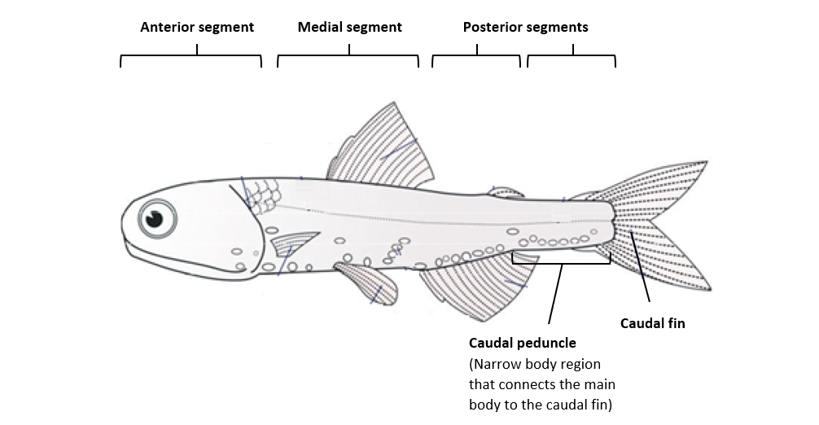

**Figure 3: A general fish body plan.** Adapted from Wilkin and Brainard (2020).

The customer requirements from 1.2 Requirements is to design a robotic fish with active head control, consisting of three joints with four rigid segments: an anterior segment (the head), a medial segment (the main body), and two posterior segments (a caudal peduncle segment and a caudal fin segment; see *Figure 4*). The first joint controls the movement of the anterior segment, the second joint controls the movement of the caudal peduncle segment, and the third joint controls the movement of the caudal fin segment. These segments are four pieces that creates the foundation for the “LEGO” framework.

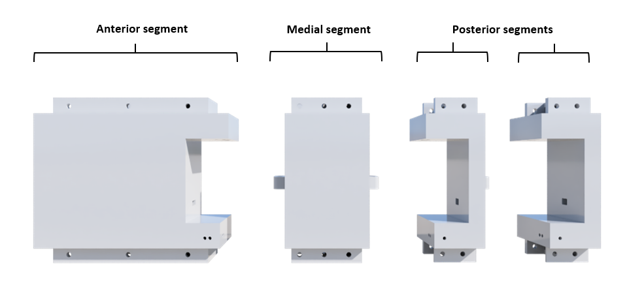

**Figure 4: 3D model of fish segments showing the anterior segment (left), medial segment (centre) and posterior segments (right).** Note that both the caudal peduncle segment and the caudal fin segment has the same design (posterior segment).

## 3.2 Segment Design

The anterior segment, the medial segment and the posterior segment are the three parts creating the basic “LEGO” framework of the robotic fish (see *Figure 5*). These parts were initially designed to be waterproof where the segments could be opened and accessed, but because of how challenging it was, a better solution was to do hardware and design changes. The segments ended up being water resistant but not waterproof.

The anterior segment is the segment that is housing the electronics (see *Figure 5*). There are slots inside that fit the necessary components and when both pieces of the segment are closed together, the components will sit rigid inside without needing to use screws. This allows for a very flexible placements of the components and for easy access when needing to remove or troubleshoot them. It also helps with keeping the design as simple as possible without the need for any advanced mechanical mechanisms.

The medial segment is the segment that houses the batteries needed to power the robotic fish, and it has enough space for two 1.5A LIPO batteries (see *Figure 5*). There are also holes for two wires to exit the segment in the direction of the anterior segment and the posterior segments.

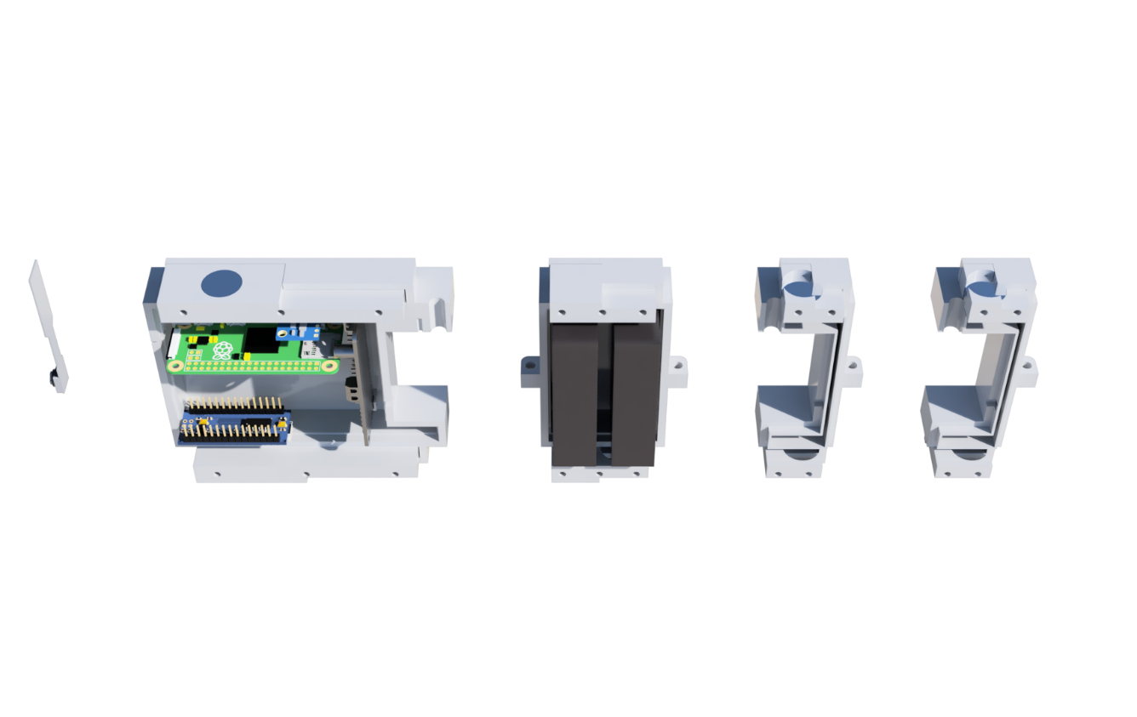The posterior segment was designed to house the servo wires to make the fish waterproof while also preserving the length of the servo wires in case if the servo where to be relocated to another position. Because of the design change where the segments did not need to be waterproof, the space inside the segment is only used to capture air for buoyancy, and the wires is directly mounted to the servo driver inside the anterior segment instead of the posterior segment.

8

7

33



43

2

1

53

6

**Figure 5**: **Open 3D model of the robotic fish showing the magnet holders with the magnets on the anterior, medial, and posterior segments.** In the anterior segment there is a camera (1), Raspberry Pi (2), Magnet holder (3), Magnet (4) IMU (5), Servo Driver (6), Arduino (7), and in the medial segment there are two batteries (8). Note that the camera is floating with a CAN wire. This wire is attached to the Raspberry Pi through the small hole on the top left. Also, the pins from the servo driver are piercing the segment body in the 3D model, this is not the case since the pins are normal to the board and not bent 90o.Note that there is no visible magnet on the medial segment because it is covered by the magnet holder mount.

## 3.3 External Body Design

The goal of the “LEGO” framework is to support different fish shaped segments that can be mounted onto the anterior, medial, and posterior segments, and thereby creating a fish looking robot. This is done using the power of magnets mounted into small magnet holders on the top and bottom of the anterior, medial, and posterior segments (see *Figure 5*). These magnet holders are then installed with screws to lock the magnets in place while also securing the two bodies creating the segment.

To attach external bodies that fit the anterior, medial, and posterior segments, they need to have the same magnet positions. This ensures that the external bodies fit to the segments they intend to fit. The magnets positions are located at an offset from the top and bottom magnet holder to make it easier to install the external bodies to the intended segments as the force form one magnet is weaker than two magnets.

The use of magnets allows for a very modular external design as the external bodies (see *Figure 6*) can more easily be removed and swapped out for other bodies compared to using screws. Another benefit of using magnets is that the external body does not need to have direct contact with the segment. This method allows for the use of a plastic bag for waterproofing which is a much easier design choice instead of waterproofing each segment as mentioned previously. This is more detailed described in 4.8 waterproofing.

The caudal fin mounted on the external posterior segment (*Figure 6*) can be removed and changed. The external body is designed with M2 screw mounts on the top and bottom side which will allow the mounted tail to sit rigid. This will result in a movement where the external body will move, and the caudal fin will follow depending on how flexible it is (see more in 6.3 Flexible Tail).

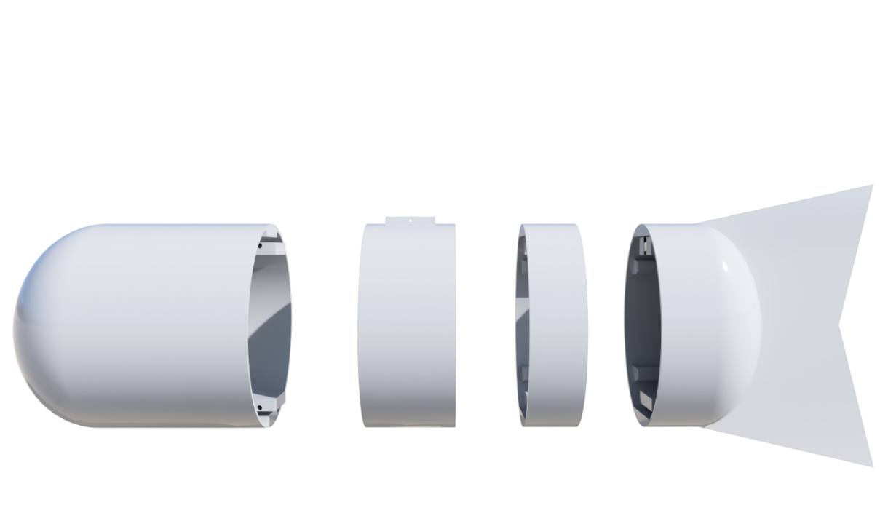

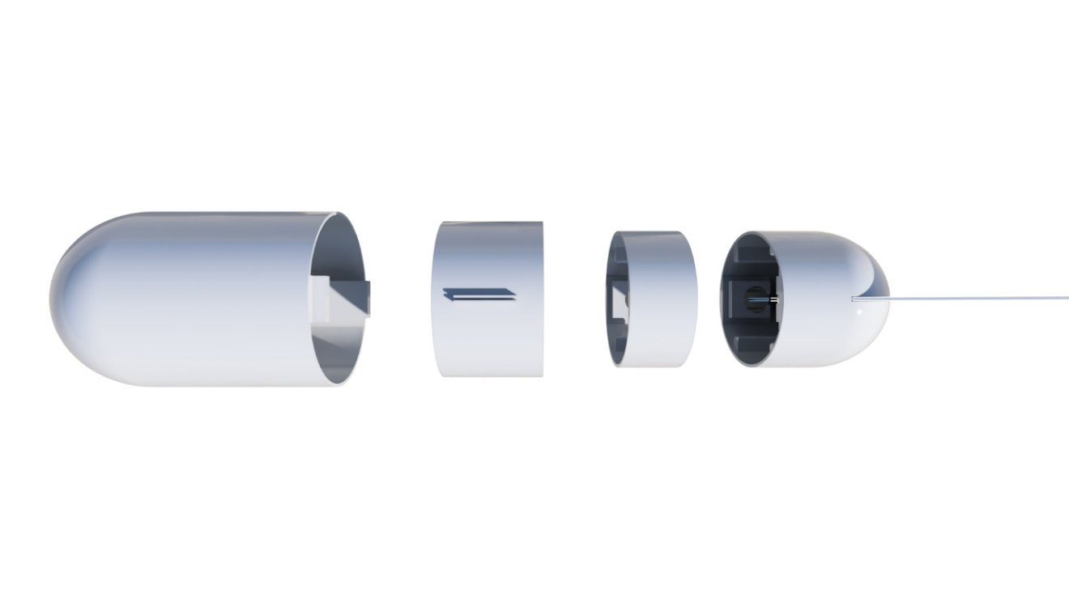

**Figure 6: External bodies displayed as a side view (top) and a top view (bottom) including the magnet holders**. The magnet location is matching the external body such that it will have the correct position on the segment when attached.

The external bodies are modelled as an eclipse as it is easier to 3D model. The external bodies attached to the anterior segment is much wider than the external bodies attached to the medial and posterior segment (see *Figure 6*). This is because the body of the fish becomes narrower the closer it is towards the caudal fin (*Figure 7*).

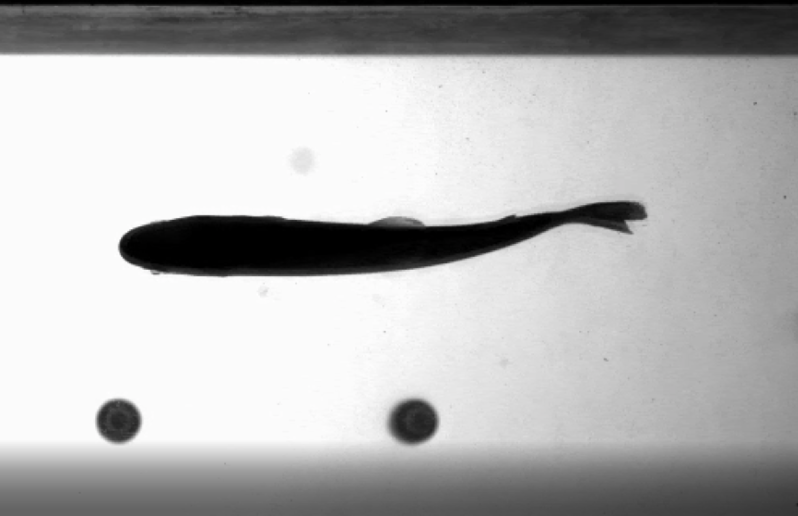

**Figure 7: A rainbow trout swimming in a flow tank shown from the bottom view.** From the experiment by Akanyeti and Liao (2013).

## 3.4 Slicer Profile

A slicer is used to convert a 3D model into a printable object. The slicer converts the .stl 3D model file to a .gcode file which the 3D printer can use to print a physical object. The .gcode file includes all the instructions needed, such as the temperature, wall thickness, layer thickness etc., and every parameter influences how strong, flexible, rigid, heavy, and waterproof the 3D print is. The values of all the parameters used in the slicer to create the physical objects in this project are stored in a slicer profile.

## 3.5 Pictures of 3D Printed Objects

Below are two pictures of the 3D printed robotic fish. *Figure 8* shows all the segments with the anterior segment opened and *Figure 9* shows the whole robotic fish assembled with a waterproof vacuum bag.

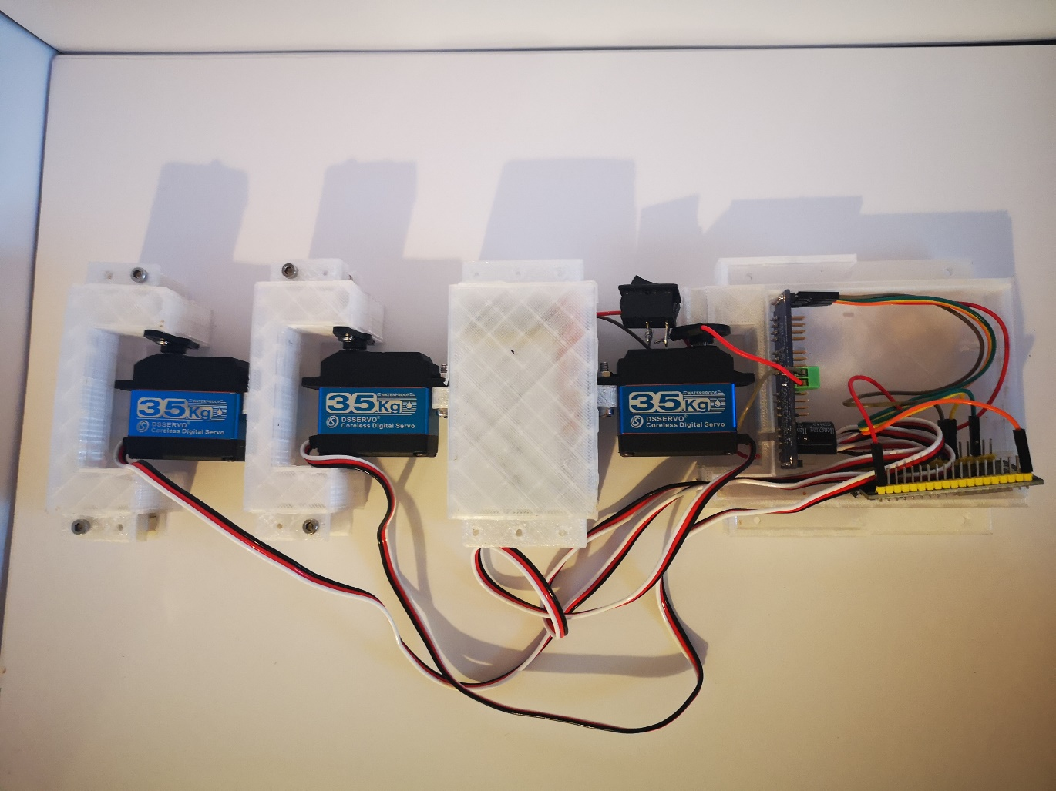

**Figure 8: A display of the segments with the anterior segment being opened to show the electronics inside.**

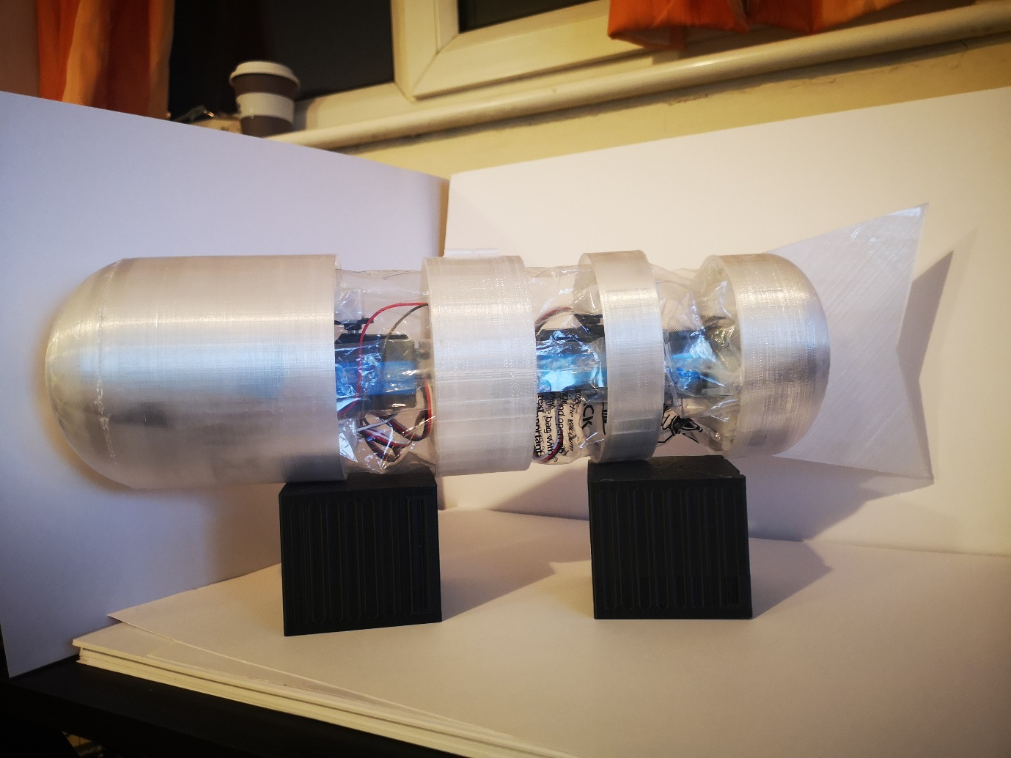

**Figure 9: A display of the fully assembled waterproof robotic fish.**

# 4 Hardware

## 4.1 Components and Schematic

The hardware consists of a microcontroller board that controls a servo driver which drives the three servos that is attached to the segments of the fish. The microcontroller board is the ESP32 and the servo driver it is controlling is the PCA9685 module. The PCA9685 is passing on the commands from the ESP32 to the DSSERVO DS3235 servos and this process is shown in the schematic below (see *Figure 10*).

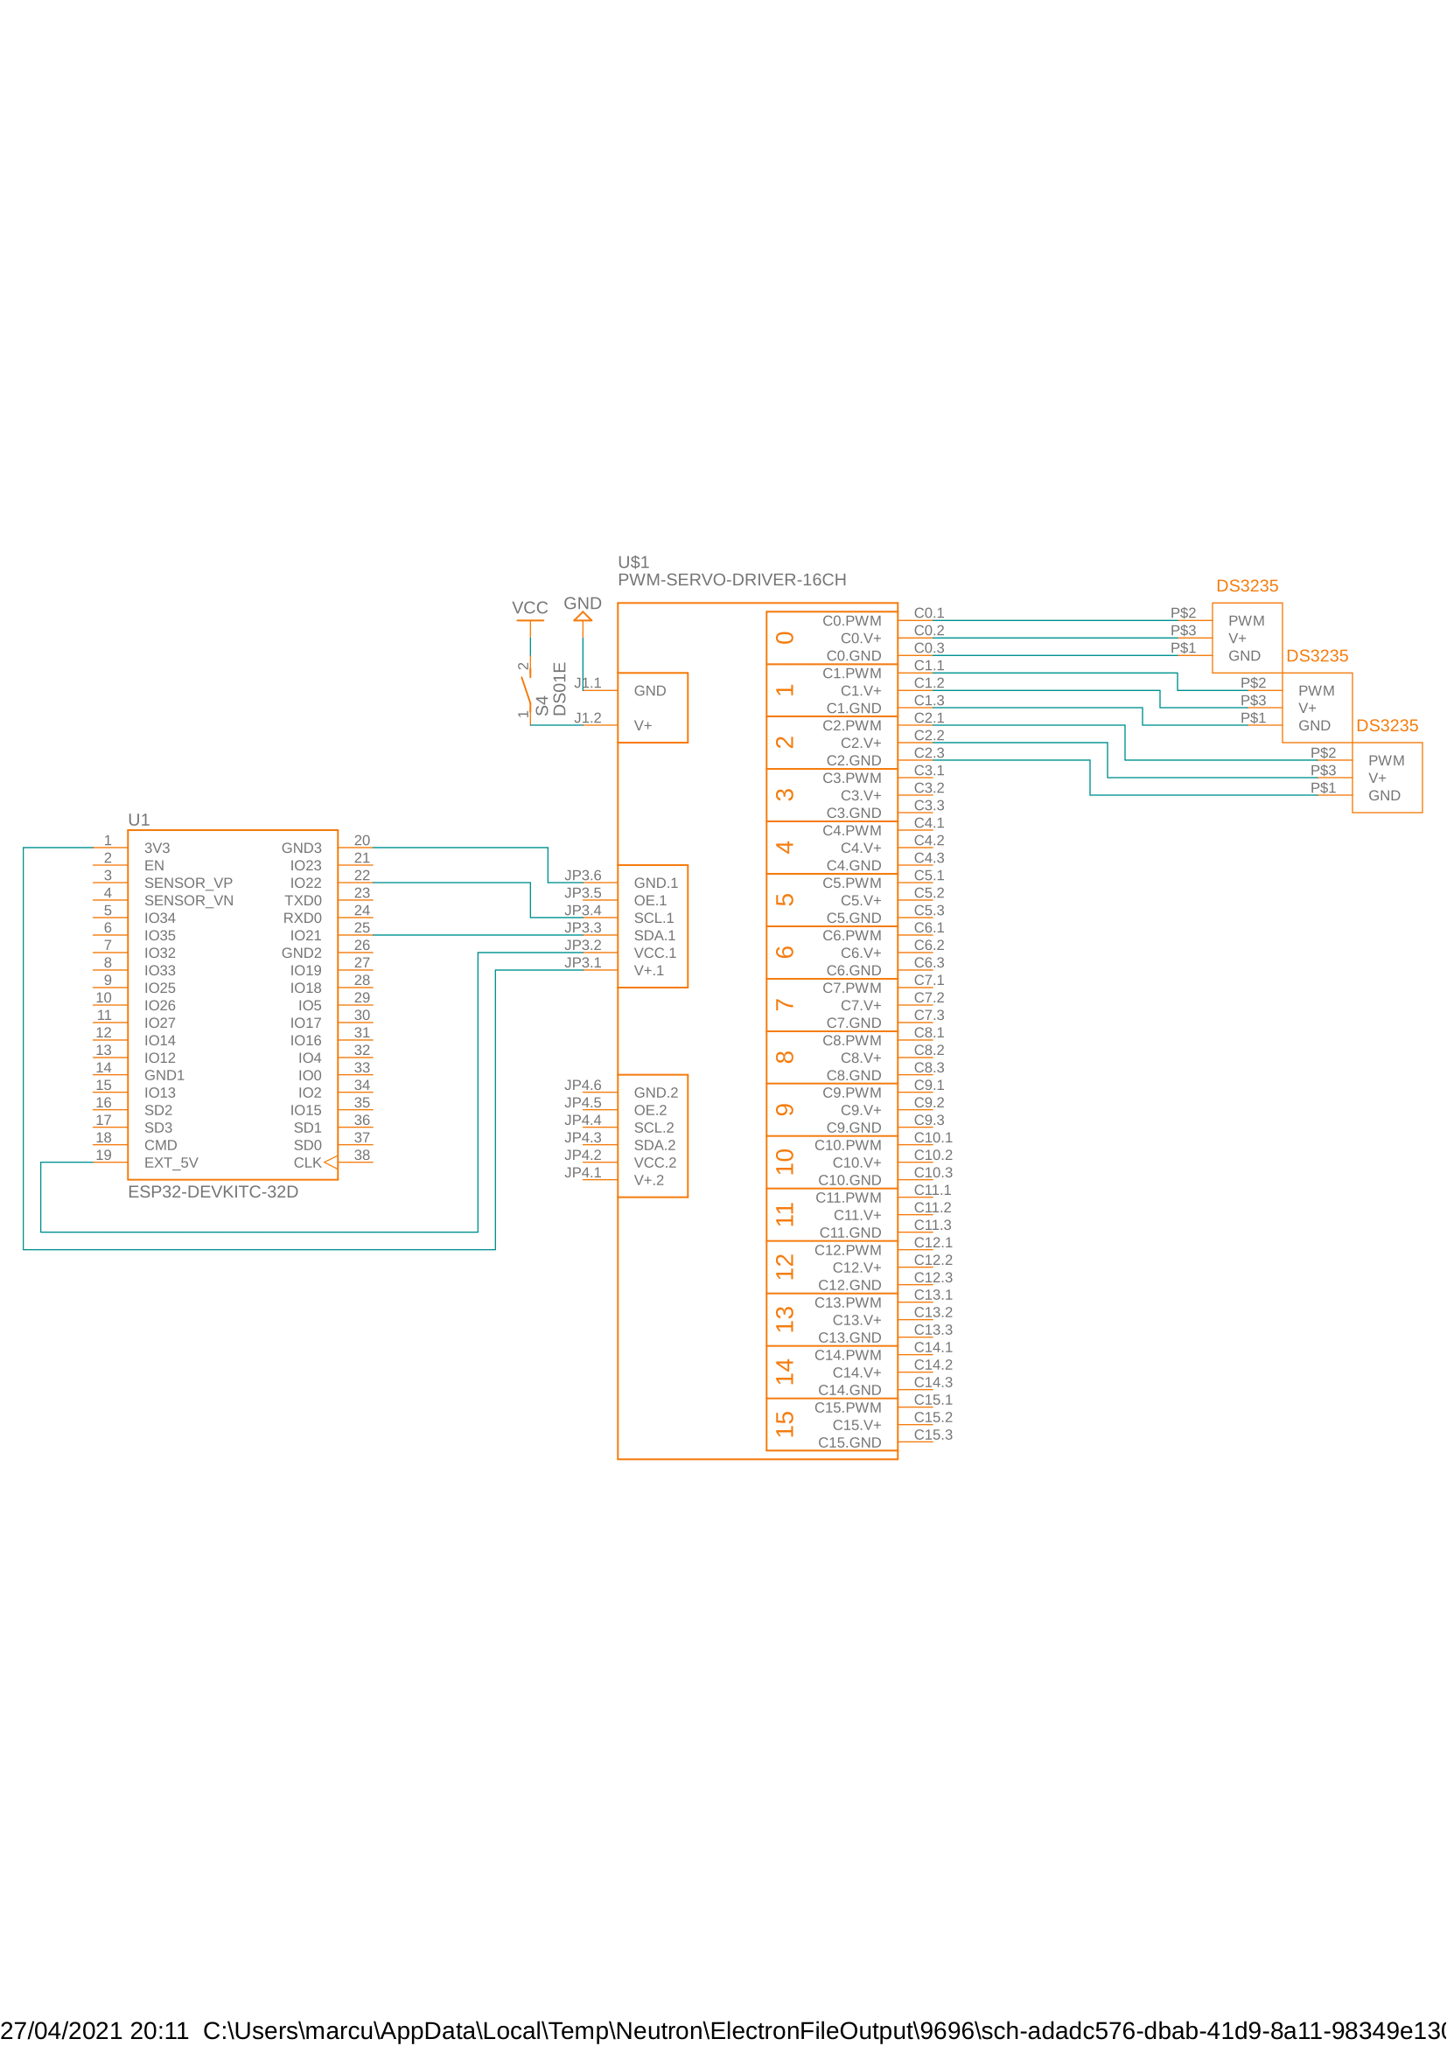

**Figure 10: Schematic showing how the ESP32 connects with the PCA9685 module and the DS3235 servos.** The VCC is 7.4V.

## 4.2 Communication Protocol

The ESP32 and the PCA9685 is communicating using a Master-Slave relationship called Inter-Integrated Circuit, or I2C, which is a low-speed serial protocol using only two wires. These two wires consist of the Serial Data (SDA) line and Serial Clock (SCL) line where the data is sent, and the speed is determined. There are four different speed settings:

* Standard Mode which has a maximum clock speed of 100KHz.
* Fast Mode which has a maximum clock speed of 400KHz.
* Hi-Speed Mode which has a maximum clock speed of 3.4MHz.
* Ultra Fast Mode which has a maximum clock speed of 5MHz.

The signal distance decreases as the speed increases,

$$t=\frac{d}{v}$$

where *t* is the amount of time the signal uses to travel across a distance *d* at a velocity of *v*, which is why electrical component cannot always handle the higher speeds. In this case the PCA9685 servo driver can handle speeds of up to 1MHz and the ESP32 can handle speeds of up to 5 MHz. This means that the common ground for both components is Fast Mode and will be the maximum speed the I2C bus can operate at. The distance between the components when installed are roughly 10 cm apart and this length will not influence the speed of the signal.

## 4.3 Microcontroller

The microcontroller board used for the real time control system is the ESP32. The ESP32 uses the NodeMCU microprocessor which has an operating voltage of 3.3V. The power supply is rated for 7V – 12V which is perfect when using a 7.4V LIPO battery and servos rated for 7.4V. When the Wi-Fi, Bluetooth, Radio, ESP32 Core, ULP Coprocessor, Peripherals and the RTC are active the ESP has a current consumption of 160 ~ 260 mAh. Due to its Wi-Fi capabilities, it can also for over the air (OTA) programming.

Note that in the 3.2 Segment Design there are an Arduino Nano and a Raspberry Pi Zero located in the anterior part (the head). This is because an earlier version of the hardware used an Arduino Nano to run the control system and the Raspberry Pi was supposed to do real time image processing. The clock speed of a 16 MHz Arduino ATmega328p chip was too slow to do the necessary real time control system together with the 1GHz Raspberry Pi which is why it was replaced by the ESP32 that has a clock speed of 160MHz. The Raspberry Pi is a viable solution to real time image processing, but the project was never developed far enough to implement it.

## 4.4 Servos

The servo used for this project is the DS3235 35Kg/cm digital servo motor. The servo is used to move the 3D printed fish segments and it uses a coreless design, which means it is a better choice for use in precision applications compared to its counterpart, a brushless design. It has a working frequency of 50-330Hz, which is how often the servo can receive commands per second. The operating voltage is from 5V – 7.4V and has a stall current (locked) of 2.3A at 7.4V. It has a range of motion of 270o and a speed of 0.11 sec/60 degree at no load, which is a frequency of 4.5 Hz for 60 Hz. As the maximum range of motion (described in *Table 3)* is 58.8 degrees this is a reasonable value. The average torque of the 35kg*cm servo along the four different segments are described in *Table 4* which shows there is more than enough torque to move the robotic fish in the air.

**Table 4: Describes the relationship between the weight of the robotic fish and the torque of the servos**. The weight of the segments is the total weight with everything installed (electrical components, battery, magnets, external bodies etc.). The centre of mass (COM) of each segment is used to do the torque required calculation. S1, S3, S4 are the joint positions (see Table 1 and Table 2 for more information) where the servos are placed. Note that the medial segment does not have an active joint.

|  |  |  |  |  |  |
| --- | --- | --- | --- | --- | --- |
| Body segments | Weight  (g) | COM  (mm) | Servo | Torque required (kg*cm) | Max torque (kg*cm) |
| Anterior | 241 | 86.25 | S1 | 2.08 | 35 |
| Medial | 360 | 63.10 | - | - | - |
| Caudal peduncle | 141 | 34.13 | S3 | 2.41 | 35 |
| Caudal fin | 111 | 61.30 | S4 | 0.68 | 35 |
| Total | 853 | 244.93 | - | 5.17 | 105 |

Due to the small scope of this project, the torque calculations needed for the servos to move the segments in a fluid, in this case water, is not calculated but rather tested in 6.2 Water . As found when testing the robotic fish in in the water, the servo motor was not strong enough to move at its rated 4.5 Hz and some alternative servo motors from Dynamixel have been evaluated for future upgrades: (1) XW540-T260-R, (2) MX-28T and (3) MX-106R.

## 4.5 Servo Driver

The servo driver used to operate the servos is the PCA9685 module. The reason for using a servo driver in the first place instead of the general Input/Output (IO) pins on the ESP 32 is due to the option of attaching up to 16 servo motors to the module while only using four wires: (1) Ground, (2) V+, (3) SDA and (4) SCL. This can be done since the servo driver operates through I2C. The advantages of using the PCA9685 are that there are minimal hardware and software changes needed when adding/removing servo motors from the robotic fish, which makes its design very modular when modifying the joints along the fish body.

The PCA9685 module requires 3.3V – 5V as VCC for the logic board and V+ voltage that powers the servo. Since the VCC and V+ are not connected the V+ voltage can be the same voltage as the servos require. When operating the PCA9685 module using I2C it draws typically 40 mA at 5V VCC.

## 4.6 Power

The robotic fish is powered using 7.4V lithium polymer (LIPO) batteries with 1500 mAh and 25C, which means that the batteries can safely operate at 1.5A for one hour or at a maximum of 37.5A for 2.4 minutes.

To get the worst-case scenario when looking at the operational time for the robotic fish, the current consumption from the different components needs to be looked at. The worst-case current consumption scenario of the:

* ESP32 is 260mAh
* DS3235 is 2.3Ah
* PCA9685 is 40mAh

The maximum current consumptions when having 1x microcontroller, 3x servos and 1x servo driver is 7.2Ah, which means that one 1.5Ah battery can last with continuous operation for at least 12.5 minutes and two 1.5Ah batteries can last 25 minutes. As the robotic fish is powered using two 7.4V 1500mAh LIPOs it can safely operate for at least 25 minutes.

## 4.7 Material

The material used to 3D print the robotic fish is polyethylene terephthalate glycol (PETG). The reason for using PETG is because it is one of the most effective materials to get water-resistant when doing fused filament fabrication (FDM) 3D printing as it has a very strong water and moisture barrier. This is because of the good layer adhesion it gets due to its high melting point (at 260oC) compared to other filaments such as polylactic acid (PLA; 180oC) or acrylonitrile butadiene styrene (ABS; 200oC).

The two other reasons for using PETG are because (1) it is relatively easy to 3D print because of how good the adhesion it has to the printing bed, which causes less warping of the material, and (2) because PETG can be both rigid and flexible, depending on how it is 3D printed. These properties can be used to create rigid segments and flexible tails/fins for the robotic fish.

## 4.8 Waterproofing

Initially the concept for waterproofing the fish was to have waterproof segments along with waterproof servo motors. To do this the segments needed to be 3D printed with a 100% infill to create a solid body, and because the segments are made up of two bodies they can be pushed together and then be tightened with M3 screws. The idea to make the segments waterproof was to have an O-ring between the two bodies and to dip the segment into a plastic or silicon dip to make sure the 3D print and wire holes did not leak any water under pressure.

The wires that would power and control the servos would run from segment to segment, which is the reason for the three wire holes in every segment (see *Figure 11)*. The idea was to then solder the wires in the middle of both segments and coat them with a silicon mask to protect the wires from corroding in the water. This silicon mask could be solder through so it would not hurt the modular design of the robotic fish when adding or removing segments.

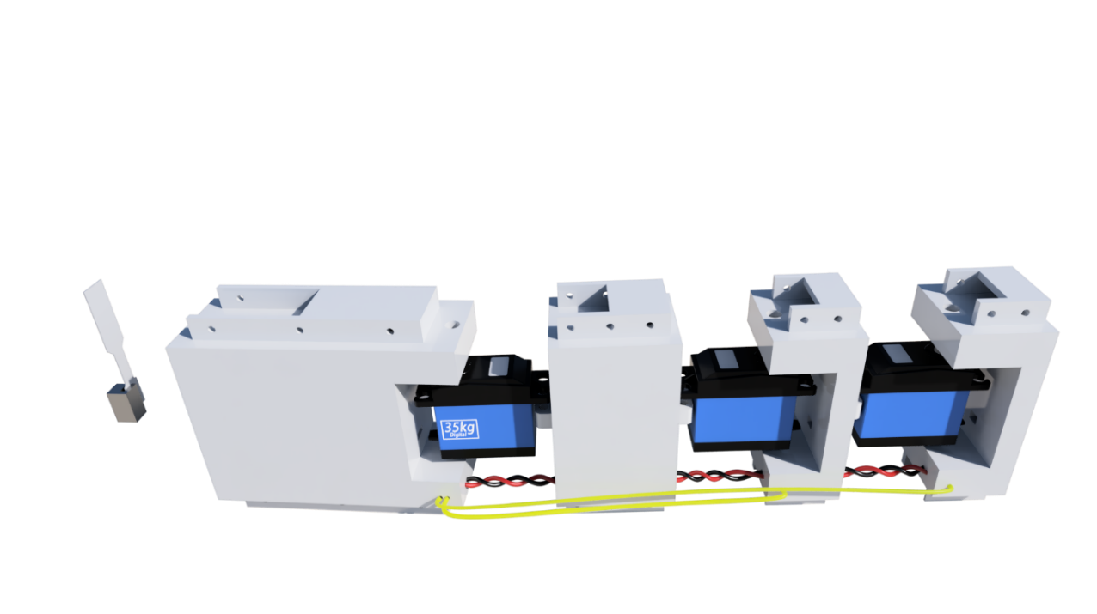

**Figure 11: Segments of the robotic fish showing how it would be wired to be waterproof**. The red wire (V+) and the black wire (GND) are powering all the segments and the yellow wire (PWM) is sending commands to the servos.

This was initially a good idea, except that whenever a segment is opened due to hardware changes or to charge the batteries, it would need to be coated again with the silicon or plastic dip. As the robotic fish needs to be charged every 25 minutes of continuous operation, this would not be a viable solution because the medial segment needs to be opened to charge the batteries. Therefore, a much simpler solution was introduced, the use of a plastic bag.

Using a plastic bag around the segments would mean that the segments and servos do not need to be waterproof, as it would not be exposed to water while being inside the plastic bag. The key was to find a plastic bag that could easily be opened, support different lengths of the robotic fish and still be waterproof, and this is when the vacuum plastic bags were introduced. As they have a dual zip-lock design, they are also designed to be airtight (hold vacuum), which means they are also watertight.

The only downside of using a vacuum bag is it will require more torque to move the segments because when there is less air in the vacuum bag, the bag will cling to the segments and create tension. To reduce this, the vacuum bags were cut to the width of the robotic fish and then melted to make it watertight again. The length of the vacuum bag had very little relevance as it could be folded to the size that fitted the robotic fish.

# 5 Software

## 5.1 Data Analysis

### 5.1.1 CSV Files

The data used for the fish analysis is gathered from the trout experiment of Akanyeti and Liao (2013). The data used from that experiment are the midline x and y coordinates along with the time stamp and it is stored as three global arrays in the software. These x coordinates, y coordinates and the time stamp are all stored in different CSV files. The coordinates for the midline along the fish over a time period is stored in the CSV file as 30 rows and 141 columns (see *Table 5*), where a row represent the specific joint along the fish and a column represent the coordinate of that joint during that time stamp. The column index is representing time index of when the coordinate was sampled, but to get the time in milliseconds the index needs to be mapped to the same column index in time stamp CSV file.

**Table 5: A small glimpse of the data in midline_y.csv.** Showing the joints (row) and the time index (column) of when the coordinate was sampled.

|  |  |  |  |  |  |
| --- | --- | --- | --- | --- | --- |
| Data from midline_y.csv | | | | | |
|  | 1 | 2 | 3 | … | 141 |
| 1 | 1.4384 | 1.4431 | 1.4431 | … | 1.4667 |
| 2 | 1.4375 | 1.4424 | 1.4419 | … | 1.4615 |
| … | … | … | … | … | … |
| 30 | 1.3820 | 1.3867 | 1.3961 | … | 1.3820 |

### 5.1.2 Joint Creation for Segments

Creating joints for segments using the CSV files in the software is fairly easy. There is a function that looks at all the joint positions hardcoded into an array in the software. This array is used to specify the location along the 30 possible joints provided in the CSV files and is visualized in *Figure 2* as red dots and in *Table 2* as joint position datapoints. These joints are then used to specify the range of motion, frequency, and phase shift for the servo motors (shown in *Table 3*).

### 5.1.3 Range of motion

The algorithm used to calculate the range of motion between joints is shown in *Figure 12* as pseudocode.

* For two joints
  + Get x, y coordinates of both joints
  + Calculate the difference in x between the two joints for the set time duration
  + Calculate the difference in y between the two joints for the set time duration
  + Use the difference in x and y to calculate all the angels in radians during the set time duration
  + Convert the angles in radians to degrees and store in an array.
  + Sort the array
  + Calculate the angle difference between the first and last item in the sorted array to get the maximum range of motion in degrees between the two joints.

**Figure 12: Pseudocode used in the data analysis software to get the range of motion between two joints.**

The range of motion is plotted to the graph to visualize how the different joints in the fish moves (see *Figure 13*).

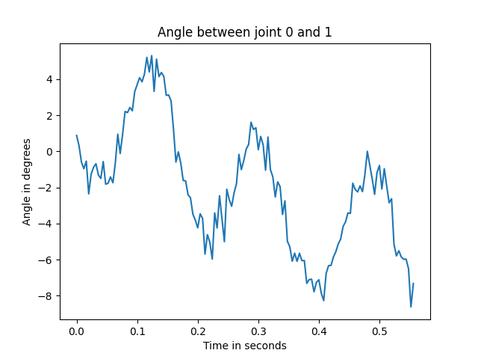 

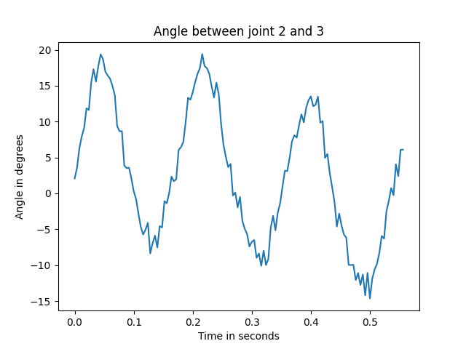 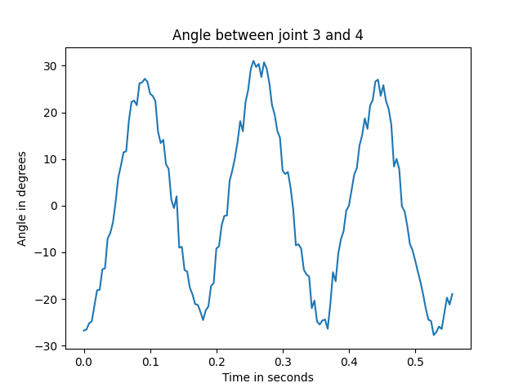

**Figure 13: Four different graphs showing five different datapoints along the fish and the angle between them.** The graph at top-left is showing the relationship between the nose (end-point) and the first segment joint (S1). The graph at top-right is showing the relationship between the first segment joint (S1) and the second segment joint (S2). The graph at bottom-left is showing the relationship between the second segment joint (S2) and the third segment joint (S3). The graph at bottom-right is showing the relationship between the third segment joint (S3) and the second segment joint (S4). Note that the signal drifts and this is due to the fish not swimming in the same location in the flow tank.

### 5.1.4 Phase shift

The algorithm used to calculate the phase shift between joints is shown in *Figure 14* as pseudocode.

* For all joints
  + Calculate the first peak
  + Store the time of when the peak happened in an array
* Find the difference in time between the reference joint peak and the other joint peaks
* Store the times in an array
* Go through the array and calculate the phase shift in degrees for all the joints.

**Figure 14: Pseudocode used in the data analysis software to get the phase shift between a reference joint and another joint.**

### 5.1.5 Frequency

The algorithm used to calculate the frequency for the joints is shown in *Figure 15* as pseudocode.

**Figure 15: Pseudocode used in the data analysis software to get the average frequency of the swimming fish.** The reason for the average frequency is that all the joints vary in frequency. This is due to the fish not swimming in a straight line in the flow tank where the data was sampled. The average frequency is used to calculate the phase shift.

* For all joints
  + Filter out all the bad peaks in the dataset
  + Calculate the average time duration from a peak to peak
  + Convert the time duration to a frequency
  + Store the frequency in an array
* Calculate the average frequencies stored in the array and to get one frequency

## 5.2 Control System

### 5.2.1 Servo Control

The servo motors have a range of 270 degrees and a pulse-width modulation (PWM) control that range from 500 to 2500 microseconds (us), and these values can be mapped to each other. A PWM signal (see *Figure 16*) has a duty cycle (on/off ratio), and this duty cycle determines the position of the servo motor. At 330Hz, or every 3030us, the servo driver sends a PWM signal to the servos that has a specific duty cycle. This means that sending a PWM signal that lasts 500 us (16.5% duty cycle) positions the servo at 0 degrees and sending a PWM signal that lasts 2500 us (82.5% duty cycle) positions the servo at 270 degrees.

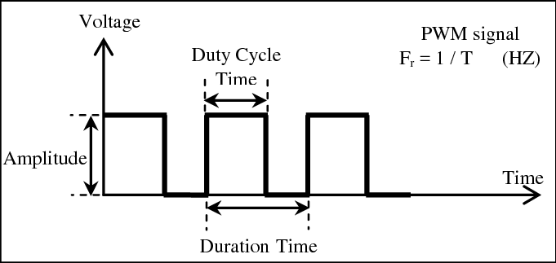

**Figure 16: PWM signal displayed over a period of time showing the duty cycle.** From Mohamed et al. (2013). Duty cycle is the ratio of the signal high time over a duration time.

In the software, the range of motion for the servos are mapped to the microseconds of the PWM signal. The variables for how much the servos can move in degrees are hardcoded into the software, and the value of these variables can be found in *Table 3*. To also get the segments in the robotic fish to go from one side to another, the segments need to have a neutral position at 135 degrees, or 1500 microseconds, or 50% duty cycle. When the range of motion for the servo motors have been transformed into an array of the duty cycle in microseconds, they can be used to control the servos (pseudocode shown in *Figure 11*).

Because of the active head design, the orientation of the anterior segment servo is mirrored (turned 180 degrees) to the other two servos that controls the caudal peduncle and caudal fin segment. This is considered when writing positions for the anterior segment as a position command with 55% duty cycle would move to the same position as a 45% duty cycle sent to the other servos controlling the caudal fin and caudal peduncle segments (see *Figure 17*).

Function “convert degrees to microseconds”

* Set neutral position to 135 degrees
* Get the min degree position depending on neutral position
* Get the max degree position depending on neutral position
* Convert the min degree position to microsecond position
* Convert the max degree position to microsecond position
* Get the difference between min and max microseconds
* Get the wanted resolution and calculate all the microsecond positions using the difference between min and max microseconds
* Invert the order of the positions for the anterior segment (because of its orientation)
* Store the microsecond positions in a global array

**Figure 17: Pseudocode for a function that converts degrees to microseconds.** The name of the function in the software is setPulseWidth(degree, joint).

Normally the microcontroller would need to send a continuous PWM signal to the servos as the servos only holds their torque during the duration time of one pulse (see *d 10*). In this case the duration time is 3030 microseconds, which means that to hold the torque for a continuous time the microcontroller needs to send a new pulse every 3030 microseconds, but this takes a lot of computational power when designing a control system. Therefore, a good solution to this is to use the PCA9685 servo driver as it will continuously send a PWM signal to the servo motor while only require one message from the microcontroller.

The Aidafruit_PWMServoDriver library is used to communicate from the microcontroller to the servo driver. The two functionalities used from this library is (1) to set the frequency the servo driver will send a PWM signal to the servo and (2) to send and update PWM signals.

### 5.2.2 Locomotion Algorithm

The robotic fish needs to have the same locomotion as a real fish to be considered a biomimetic robotic fish. When a fish swims it generates the motion of a sinusoidal wave (sinewave) with different amplitudes and phase shifts. For simplicity, the sinewave generated by the fish movements can be approximated to a triangle wave (see *Figure 18)*. This triangular wave can then be used to calculate the servo motors position depending on the resolution and range of motion.

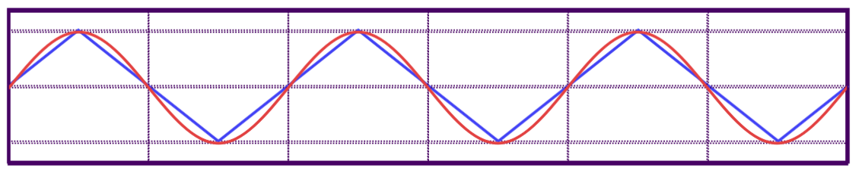

**Figure 18: A sinewave (red) on top of a triangle wave form (blue).**

These servo positions are calculated once for every joint in the beginning of the program and stored in an array. This array is then used to get the next servo position command when the servo is being requested to move. This is more efficient than calculating the servo motors position in real time whenever it is doing a new movement.

As discovered in *Table 3*, the frequency, range, and phase shift need to be considered when determining which servo motor to move to create an accurate fish movement. The anterior segment has a phase shift of 0 degrees, the caudal peduncle has a phase shift of 181.36 degrees and the caudal fin has a phase shift of 291.67 degrees. The sequence of when the three servo motors moves are, firstly, the anterior joint (S1), secondly, the caudal peduncle joint (S3), and finally, the caudal fin joint (S4). This phase shift is shown in *Figure 19*.

In the software the phase shift is converted to a time shift, where the time shift is determined by the frequency and phase shift. This means that the servos have a time delay instead of a degree delay to determine when they are to move. This time shift is applied at the beginning of the program and is present until the program is terminated. In this way when the servo position updates, it already has a built in time shift as they operate at the same frequency, which means that there are no additional steps to include a time shift in the software for when the servo motors update their positions.

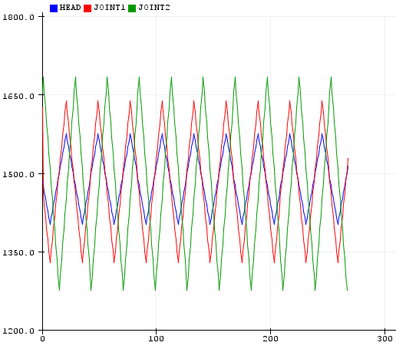

**Figure 19: Displays the relationship between the anterior (blue), caudal peduncle (red) and caudal fin (green).** The relationships shown are the amplitude in PWM (y-axis) where 1500 us is the neutral position. The x-axis shows the number of positions moved by the servos and relates to the frequency. Note that the anterior segment and the caudal peduncle has a phase shift of 180 degrees, but it cannot be seen in the graph. This is due to the 180 degree difference in orientation of the anterior segment joint compared to the caudal peduncle and caudal fin segment joints.

The range of motion can also bee seen in *Table 3*  as degrees, and in *Figure 13* as an amplitude with a duty cycle of PWM signal with a 3030 microsecond duration time where 1500 microseconds is the neutral position.

The medial segments have a frequency, phase shift and range of motion as seen in *Table* 3, but no active joint. This means that the medial segment will move passively between the anterior segment and the posterior segment and adapt the frequency and phase shift from the other segments, but these might not be the same values that was extracted from the fish data analysis (see *Table 3*). The range of motion on the other hand can be shared by the other segments, and in this case, it is shared evenly between the anterior and caudal peduncle segment in the software. This compensates the loss of an active joint in the medial segment and the fish locomotion should not differentiate too much from what was found in 2 Fish Analysis.

Once all of these initializations have been done, the fish locomotion is fairly simple and explained in pseudocode in *Figure 20*.

**Figure 20: Pseudo code for the fish locomotion.**

Function “loop”

* Initialize values and servo positions (Do once)
* If it is time to move the anterior joint to the next position, do:
  + Update and set position(anterior)
* If it is time to move the caudal peduncle joint to the next position, do:
  + Update and set position(caudal peduncle)
* If it is time to move the caudal fin joint to the next position, do:
  + Update and set position(caudal fin)

The servo position is determined by the update servo position function. The update position function has a record of the servo motors current position and its five modes where the fish swims straight forward (*Figure 21*), the fish swims gradually to the left (*Figure 22*), the fish swims gradually to the right (*Figure 23*), the fish lower-body swim forward, and the head is facing left (*Figure 24*), the fish lower-body swims forward, and the head is facing right (*Figure 25*). The servo motors have an operating range for each mode.

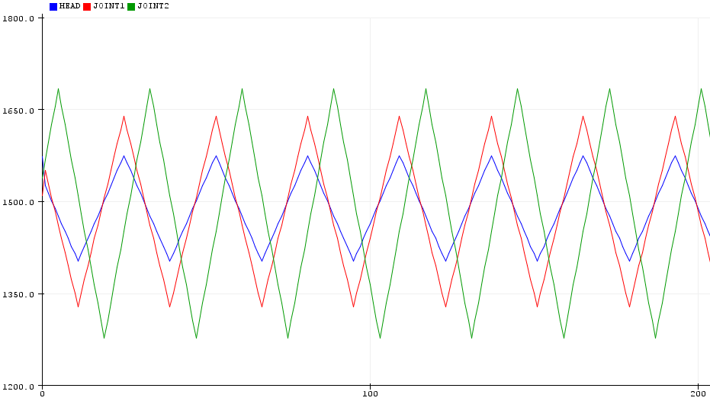

**Figure 21: Graph of mode 1**. Increment position until max position is reached, then decrement until min position is reached, and repeat.

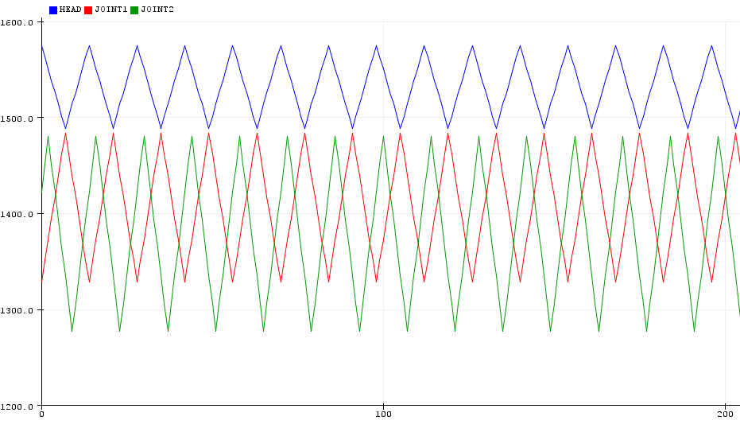

**Figure 22: Graph of mode 2.** Increment position until neutral position is reached, then decrement until min position is reached, and repeat. Note that the anterior segment is oriented 180 degrees which causes it to be on the other side of the 1500us natural position when swimming.

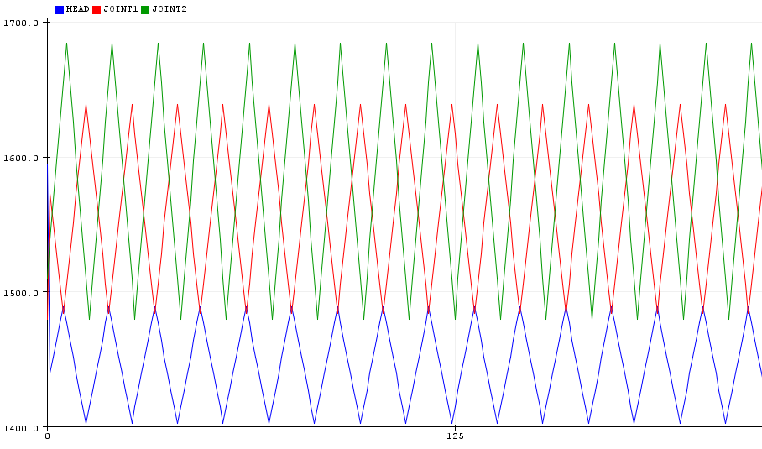

**Figure 23: Graph of mode 3.** Increment position until max position is reached, then decrement until neutral position is reached, and repeat. Note that the anterior segment is oriented 180 degrees which causes it to be on the other side of the 1500us natural position when swimming.

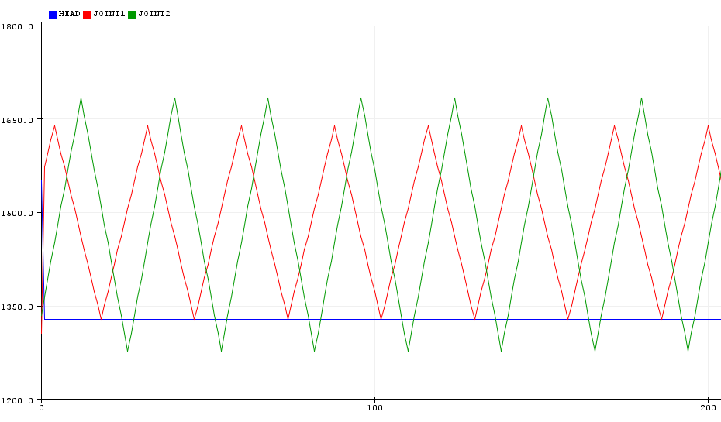

**Figure 24: Graph of mode 4.** Only caudal peduncle and caudal fin joint: Increment position until max position is reached, then decrement until min position is reached, and repeat. Only anterior joint: hold min position.

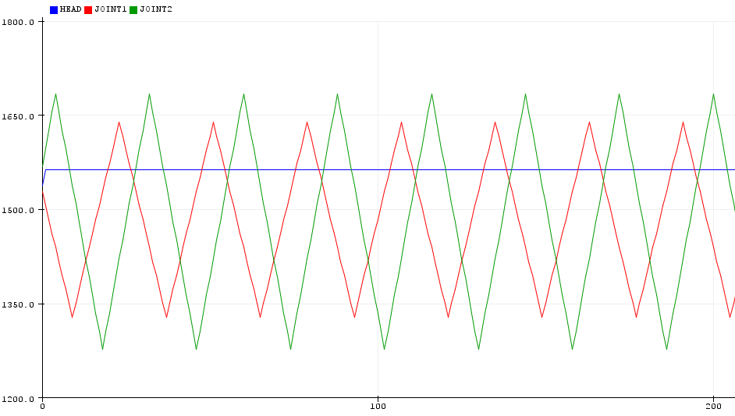

**Figure 25: Graph of mode 5**. Only caudal peduncle and caudal fin joint: Increment position until max position is reached, then decrement until min position is reached, and repeat. Only anterior joint: hold max position.

### 5.2.3 Over the Air (OTA) programming

The anterior segment needs to be opened every time the microcontroller needs to update its software, and this takes a lot of time when updating parameters in the software as the frequency, range of motion, phase shift and mode. This is because the anterior segment is in a vacuum bag with all the other segments with external bodies on top. To get inside the anterior segment, all the external bodies need to be removed and the segments needs to be extracted out of the vacuum bag. Then four M3 screws needs to be removed from the two segment bodies and the servo motor and servo mount needs to be removed. When all of this is done, the microcontroller can be programmed through a micro USB. When the microcontroller is finished programmed, everything needs to be assembled again plus checking that the vacuum bag is waterproof.

Over the air programming is very useful tool that enables the microcontroller to be programmed over Wi-Fi, which means that the anterior segment does not need to be opened and can stay in the vacuum bag with the external bodies on top. This is done by setting the SSID (name) and the password for the preferred Wi-Fi in the software and the IP address is shown on the IDE. The IP address is then used instead of a communication (COM) port, which the micro USB uses, and a sketch with the software can be sent and uploaded to the microcontroller. In the current software the microcontroller does not execute the program unless it is connected to a Wi-Fi with the SSID and password set in the software. The software also looks for a sent sketch every second instead of continuously to reduces the power consumption.

Over the air programming works on the ESP32 together with the ESPmDNS, WiFiUdp and ArduinoOTA libraries. The OTA part of the software is inspired by Last Minute Engineers (2021).

# 6 Testing and Results

## 6.1 Air

The purpose of air testing the robotic fish is to check for errors in hardware and software before committing to putting it in water. The first test done was to check for hardware issues when the segments and electronics was mounted together. The first noticeable issue was that the servo mounts could not hold the weight of the segments and was slightly tilted vertically (can be seen in *Figure 9*). The cause of the tilt is due to the fact that the servo mount has a limited vertical contact point to the segments.

Another issue discovered was that the magnets from the external body would sometimes stick to the magnet holders on the segments when assembling/removing them. The cause of this is because of the place the magnets is stored on the external body wears out after taking them in and out. A solution to this problem is to apply a little bit of glue to the magnet and slide it into the magnet position on the external body.

The servo motors where then tested to check the torque, frequency, and range of motion of the different joints. The servo motors moved the segments without any problem which validates the calculations from *Table 4*. The torque seemed fine even at extreme frequencies (up to 7.5 Hz), but as the frequency got higher, the temperature of the servos got dangerously high. During the higher frequencies, the range of the servos became less and less as they could not move fast enough to complete the position commands before a new position command was sent by the microcontroller. The range of motion did not seem to be affected at frequencies under 4 Hz.

The software sent output signals shown in *Figure 21* to the servo motors. This resulted in the servo creating a movement that resembles the fish locomotion shown in *Figure 2*. Unfortunately, there was not enough time to do a scientific comparison to between the fish data locomotion and the robotic fish locomotion.

## 6.2 Water

Before putting the robotic fish in water, the vacuum bag needed to be tested empty under pressure. This was to see if the zip-lock mechanism would hold the water pressure. The vacuum bag was placed at the bottom in of small box with 60 cm depth filled with water for 1 minute. The vacuum bag did not release air bubbles during that time and was confirmed to be waterproof.

When the fish was first put in water, it was floating on top of the water sideways. This was due to the high buoyancy force applied on the robotic fish. The solution to fix this problem was to mount pieces of iron on the bottom of the external segments. The iron bars were mounted on the outside and was held in place by the magnet located inside the external body. Almost 600g of iron bars was mounted to the external body for the robotic fish to have the right buoyancy and swim vertically in the water.

When the fish was put in water with the added weight, the segments was not tilted anymore as described in the air testing. The cause of this is due to the vacuum bag equally spreading out the buoyancy force that tries to lift the segments up to the water surface.

When the robotic fish was tested with a frequency of 4Hz in the water it did not manage to move at the range specified. The frequency was lowered to 1Hz and the range of motion was no longer affected. This is because the speed is proportional to the torque (see *Figure 26*), and the servo motors require more torque to move water than air. The servo got very hot when continuously operating the robotic fish at 1Hz in the water, but colder temperatures in the water helped to cool down the motors.

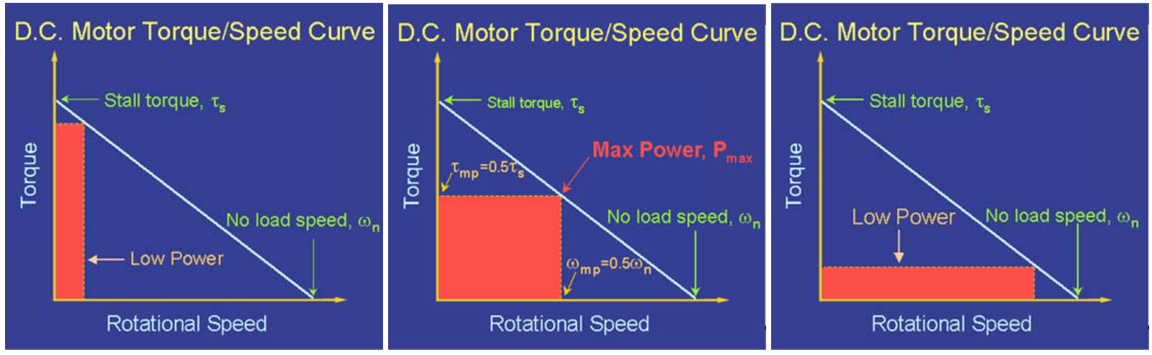

**Figure 26: Shows the power, speed, and torque relationships.** From Page (1999).

Unfortunately, there was not enough time to do a scientific comparison to between the fish data locomotion and the robotic fish locomotion when the fish moved in water.

# 7 Evaluation

## 7.1 Project Aims

The project aims are described in 1.2 Requirements. Not every requirement was achieved due to the big scope of the project and the limitations of access to resources following the COVID-19 situation, but a strong foundation was made. A biomimetic robotic fish inspired by a rainbow trout was created using the fish data gathered from 2 Fish Analysis to determine optimal joint positions along the fish. A control system was created from three servos to mimic the locomotion of a swimming and turning fish. The actuation system was design to have active head control and a framework was created to achieve a modular design for the robotic fish.

## 7.2 Testing

Everything was created and developed in the author’s home, and lack of access to equipment delayed the testing prosses. The inability to assess the research questions discussed in the report is mostly because the robot fish could not be tested in a swimming pool, but rather in a small waterproof box. This allowed for limited testing and this issue should have been addressed at an earlier stage of the project to ensure that the experiments could be done and analysed in time for the report.

## 7.3 Future Work

Future work that can be done with the robotic fish is to answer the research questions discussed in the report with proper scientific experiments. As the robotic fish do not need any further development to do these experiments, an upgrade to the CAD design from the non-hydrodynamic cylinder shape to a more fish-like shape would likely provide more accurate results in terms of fish locomotion.

A lot of improvements can be made to the hardware and software as the control system is only using three servos, a servo driver and a ESP32. The control system is missing a camera, raspberry pi, current reader and an IMU. Integrating these components into the software is a fairly big task and can be explored in the future.

Also, stronger servo motors are needed as they were struggling to swim in the water at lower frequencies compared to what was explored in 2 Fish Analysis. If the servos are changed, the CAD model needs to be adjusted to the new servo size and this is something that can be explored in future work.

## 7.4 Conclusion

A modular 3D printed biomimetic robotic fish has been created to explore new research in the field of biomimetic autonomous underwater vehicles. The design of the robotic fish was created by analysing how a trout swims in a flow tank from the experiment by Akanyeti and Liao (2013) and by looking at fish parameters from Fetherstonhaugh et al. (2021). A low-level control system was designed to actuate the robotic fish using three servos at optimal joint positions to create the locomotion of fish. One of the important research questions in this report was looking at how an active head design can increase swimming efficiency as discovered in the research done by Akanyeti et al. (2016). Due to the time scope of this project, the research questions discussed in this report was not scientifically tested, but it is something that the author and the customer will do in the future.

# 8 References

Akanyeti, O., and Liao, J. C. (2013). The effect of flow speed and body size on Kármán gait kinematics in rainbow trout. *Journal of Experimental Biology*. Vol. 216, no. 18, pp. 3442-3449.

Akanyeti, O., Thornycoft, P., J., M., Lauder, G., V., Yanagitsuru, Y., R., Peterson, A., N., and Liao, J., C. (2016). Fish optimize sensing and respiration during undulatory swimming. *Nature Communications*. Vol. 7, no. 11044.

Anderson, J., M., Streitlien, K., Barrett, D., S., and Triantafyllou, M., S. (1998). Oscillating foils of high propulsive efficiency. *Journal of Fluid Mechanics*. Vol. 360, pp. 41-72.

Ay, M., Korkmaz, D., Koca, G., O., Bal, C., Akpolat, Z., H., and Bingol, M., C (2018). Mechatronic Design and Manufacturing of the Intelligent Robotic Fish for Bio-Inspired swimming Modes. *Electronics*. Vol. 7, no. 7, pp. 118.

Bal, C., Koca, G., O., Korkmaz, D., Akpolat, Z., H., and Ay, M. (2019). CPG-based autonomous swimming control for multi-tasks of a biomimetic robotic fish. *Ocean Engineering*. Vol. 189

Chen, D., Wu, Z., Yo, J. (2019). Effect of Compliant Passive Joint on Swimming Performance for a Multi-Joint Robotic Fish. *International Conference on Robotics and Biomimetics*. Dali, China, Dec 2019. IEEE.

Fetherstonhaugh, S. E. A. W., Shen, Q., and Akanyeti, O. (2021). Automatic segmentation of fish midlines for optimizing robot design. *Bioinspiration & Biomimetics*. Vol. 16, no. 3.

Hirata, K., Takimoto, T., and Tamura, K. (2000). *Study on turning performance of a fish robot*. Available at: <<https://www.nmri.go.jp/oldpages/eng/khirata/list/fish/isamec2000.pdf>> [Accessed 06 May 2021].

Koca, G., O., Korkmaz, D., Bal, C., Akplat, Z., H., and Ay, M. (2016). Implementations of the route planning scenarios for the autonomous robotic fish with the optimized propulsion mechanism. *Measurement*. Vol. 93, pp. 232-242.

Page, M. (1999) *Understanding D.C. Motor Characteristics*. Available at: <<http://lancet.mit.edu/motors/motors3.html>> [Accessed 07.05.2021]

Last Minute Engineers (2021). *ESP32 Basic Over The Air (OTA) Programming In Arduino IDE*. Available at: <<https://lastminuteengineers.com/esp32-ota-updates-arduino-ide/#ways-to-implement-ota-in-esp32>> [Accessed 06 May 2021].

Mohamed, M., A,. A., Elmahalawy, A., and Harb, H., M. (2013). Developing the pulse width modulation tool (PWMT) for two timer mechanism technique in microcontrollers. S*econd International Japan-Egypt Conference on Electronics.*  Cairo, Egypt, Dec 2013. IEEE.

Triantafyllou, M., and Triantafyllou, G. (1995). An Efficient Swimming Machine. *Scientific American*. Vol. 273, no. 3, pp. 64-70.

Wilkin, D., and Brainard, J. (2020). *Structure and Function in Fish*. In *CK-12 Biology Concepts*. CK-12 Foundation. Palo Alto, CA, USA.

Yo, J., Wang, L., Shao, J., and Tan, M. (2009). Control and Coordination of Multiple Biomimetic Robotic Fish. *IEEE Transactions on Control Systems Technology*. Vol. 15, no. 1, pp. 176-183.

Zhong, Y., Li, Z., Du, R. (2017). A Novel Robot Fish With Wire-Driven Active Body and Complaint Tail. *Transactions on Mechatronics*. Vol. 22, no. 4, 1633-1643. IEEE

# 9 Appendices

## A Third-Party Code and Libraries

### A.1 Python Libraries

The python libraries used are:

* Numpy – Used for its array and the ability to read .csv files. Available under BSD license
* Math – Used to calculate an arctan equation and convert radians to degrees. Available under BSD license
* Matplotlib – Used to create animations and graphs to visualise data. Available under BSD license
* Scipy.signal – Used to detect peaks in a signal. Available under BSD license

### A.2 ESP32 Libraries

The libraries used by the ESP32 are:

* Arduino.h – Used to get the Arduino environment into visual studio code. Available under GNU license.
* Wire.h – Used for I2C communication between devices. Available under GNU license.
* ESPmDNS.h – Used for OTA. Available under MIT license.
* WiFiUdp.h – Used for OTA. Available under GNU license.
* ArduinoOTA.h – Used for the ability to send sketches over Wi-Fi. Available under GNU license.
* Adafruit_PWMServoDriver.h – Used for the communication between the microcontroller and the servo driver. Available under BSD license.

## B. Ethics Submission



 